|  |  |  |
| --- | --- | --- |
| **Rothamsted weather data – exercise for secondary schools** |  |  |

# 2) Monthly weather data since 1878:

# Use the dataset SCHOOLMETMTH

**Important:** You will require a password to extract data from the e-RA database – contact the e-RA curators in advance by email to obtain a password (res.era@rothamsted.ac.uk).

In this exercise, we are looking at how to extract data from our database for one or more months, and some of the ways we can analyse this data. Rothamsted has developed e-RA, the electronic Rothamsted Archive, to keep the results of **the long term experiments** and other information like **weather data**.

# *The weather for one month*: Select a month and year from SCHOOLMETMTH. Select SCHOOLMETMTH, check (tick) all left hand boxes, and check ‘MONTH’ and ’YEAR’ on the right hand box (as shown below). Then go to ‘Filter’ and choose your month and year. Select ‘accept’ then go to ‘Retrieve’ and select ‘extract data’.

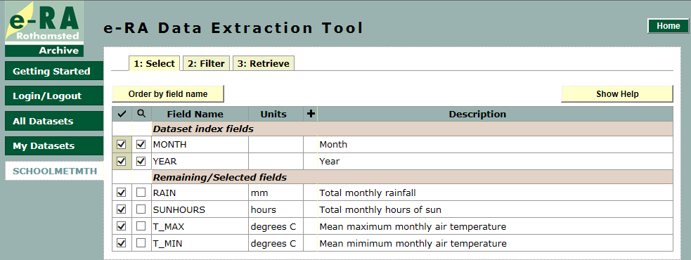

On this month _______________ and year _____________

There were ______________mm of rain. There were __________ hours of sun.

The mean maximum air temperature (T_MAX) was ______________ °C

The mean minimum air temperature (T_MIN) was __________________°C.

1. ***The overall mean temperature*** is the mean (average) of the maximum and minimum temperatures. For example, in June 1900, **T_MAX** = 17.75 °C, **T_MIN** = 8.57 °C.

The mean temperature is (T_MAX + T_MIN) / 2 = (17.75 + 8.57) / 2 = **13.16 °C**

Calculate the mean monthly temperature for the month and year you have chosen:

The mean temperature for the whole year would be the average of all the monthly means.

1. ***The weather for 120 years***: Now let’s see what has happened to temperature at Rothamsted over the last 120 years. The table gives the mean temperature in sets of10 years over the last 120 years: complete the graph by plotting the data in the table:

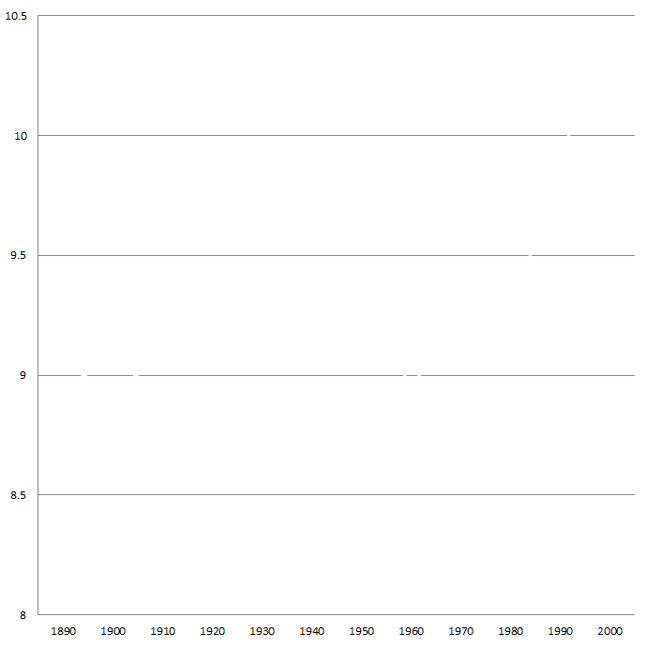

|  |  |
| --- | --- |
| 1890-99 | 9.04 |
| 1900-09 | 8.94 |
| 1910-19 | 9.07 |
| 1920-29 | 9.02 |
| 1930-39 | 9.24 |
| 1940-49  Temperature degrees C | 9.36 |
| 1950-59 | 9.32 |
| 1960-69 | 8.95 |
| 1970-79 | 9.25 |
| 1980-89 | 9.22 |
| 1990-99 | 9.93 |
| 2000- | 10.4  Date |

|  |  |
| --- | --- |
|  |  |

1. ***Your turn….!*** Now you extract data for some years from e-RA dataset ‘SCHOOLMETMTH’ and use excel to analyse it. We have given 2000 as an example…

|  |  |  |  |
| --- | --- | --- | --- |
| **Year** | 2000 |  |  |
| **Month with hottest T_MAX** | Aug 22.14 ⁰C |  |  |
| **Month with coldest T_MIN** | Jan 1.58 ⁰C |  |  |
| **Mean annual temperature** | 10.20 ⁰C |  |  |
| **Sunniest month** | Aug 201.3 hrs |  |  |
| **Wettest month** | Apr 132.5 mm |  |  |
| **Total rainfall for the year** | 973.5 mm |  |  |